INGREDIENTS  (serves 3-4)  - 1 butternut squash  - 1 red pepper  - 1 tin of beans (butterbeans, canellini, chickpeas or kidney beans)  - 2 handfuls Pumpkin seeds (dry roasted)  - Rocket  - Spinach  - White / red onion  - Olive oil  - 1 Avocado  - Cherry tomatoes  - Sugar-snap peas  - Halloumi (1 pack)  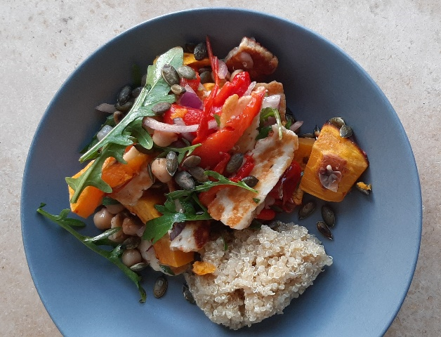 |  |  | METHOD  - Turn on fan oven to 180˚  - Peel and chop the butternut squash into similar size pieces and place onto baking tray. Drizzle with a small amount of olive oile, salt, pepper and option of smoked paprika / turmeric. Roast for 25 minutes or thereabouts. Turn regularly.  - Put the red pepper into the oven whole and roast for 10 minutes or thereabouts. When cooked, deseed and slice into strips.  - Drain and rinse the beans well under cold water.  - Place pumpkin seeds on hot pan without any oil. Lightly toast them by turning regularly. Do not leave unattended as they burn very quick! Place in bowl and set aside.  - Half the onion and chop into thin slices. In a small dish, marinade the onion with some extra virgin olive oil and/or balsamic vinegar. Leave for at least 10 minutes.  - Slice halloumi into even pieces and fry on a medium on both sides until golden brown.  - Peel, destone and chop the avocado.  - Combine all the ingredients together in a large bowl. Mix well and serve with below dressing. Enjoy!
 | Honey & Mustard Dressing
 | Serve over salmon, poached eggs or salads. Make extra and keep it in the fridge.
 | INGREDIENTS  - ½ extra virgin olive oil  - ½ fresh lemon juice  - 1 teaspoon organic honey  - 1 teaspoon whole grain mustard  - Fresh black pepper  - Himalayan rock salt  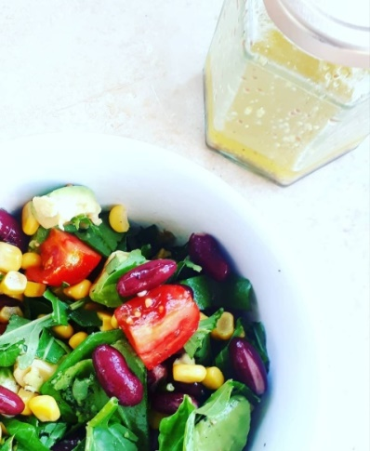 | METHODS  - In empty glass jar add olive oil and lemon juice (they will separate so you can see when you’ve reached about ½ and ½ of each).  - Add honey, whole grain mustard and a crush of salt and pepper. Close lid and shake. Tweak to suit personal taste.

