Serve with “live” natural yogurt or plant milk. Add fresh fruit on top.

INGREDIENTS  - 2 tbsp coconut oil  - ½ tbsp honey or maple syrup  - 200g whole oats  - 2 tbsp flaked almonds  - 2 tbsp walnuts nuts  - 2 tbsp pumpkin seeds  - 2 tbsp pecans  - 2 tbsp sunflower seeds  - 2 tbsp flaxseeds / linseed  - 5 dates chopped up small  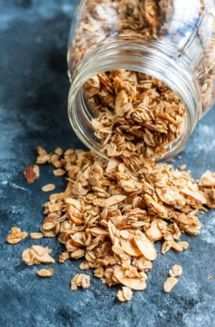 | METHODS  - Preheat oven to 170º.  - Roughly chop all nuts & seeds (depending on desired texture).  - Place all the ingredients on a baking tray including a chunk of coconut oil. Mix well with your hands.  - Place in the oven for 1 minute to melt the coconut oil and mix thoroughly again.  - Leave in the oven for 10-15 minutes until lightly toasted, stirring every few minutes (warning they will burn if left too long!)  - Remove from oven, cool and store in airtight container for up to 3 weeks.  TIP – this is just a guide recipe and you can vary the nuts / seeds / oats and the ratios depending on what you have in the press.  Option to add some raw cacao powder for chocolate taste, cinnamon or a small amount of vanilla extract.  Experiment and see what you like!

